Name ______________________ Date _________ Teacher: _________

Partner’s Name(s) ________________________

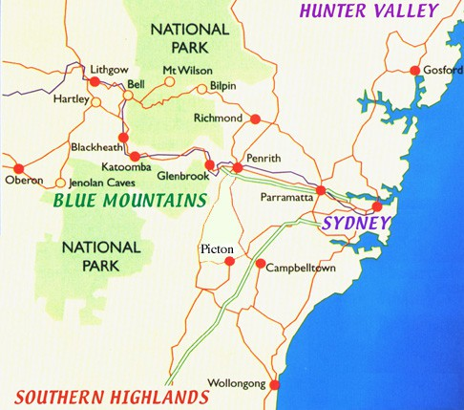**Estimating Plant Populations – Form A**

**Introduction**: *Imagine that you are an ecologist hired to find the population size of a plant species in a 1,000 square-km region. How can this be done without counting every single individual? Which factors could affect the results of your study? In this activity, we will find the approximate population size for Gum trees in the Blue Mountains (west of Sydney(.*

**Materials**: Calculator

**Procedures**:

1. A common method for estimating plant populations is the Quadrat method. A quadrat is a square that marks off a section of a field. For each type of plant within the quadrat, scientists record how many specimens are found. Using several quadrats within an area helps to establish a population average for that region.

2. Look at the aerial view of a square-km in the Blue Mountains **with each dot representing a gum tree**. Randomly select 5 letters (A to J) from the aerial view and write them in the 1st column of the table. Randomly select 5 numbers (1 to 10) and write them in the second column. Use these as coordinates to count the number of trees (dots) per quadrant.

**AERIAL VIEW**

|  |  |  |
| --- | --- | --- |
| **Letter** | **Number** | **Number of Trees in this quadrant** |
|  |  |  |
|  |  |  |
|  |  |  |
|  |  |  |
|  |  |  |
| Total Trees number in 5 quadrants (1/20 of a sq km) | | = |
| Total Trees estimate in 100 quadrants – the whole square (1 sq km) | | = |
| Total tree estimate in 1000 sq kms | | = |

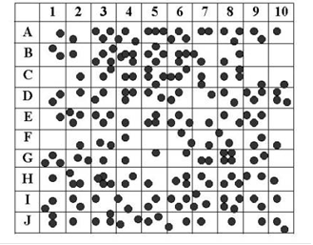

**Questions*:***

1. Go to 5 other people in the class and copy down their estimate of total number of trees in 1000 square kms of the Blue mountains

_________ _________ _________ _________ _________

1. Compare your estimate of tree number to the others. Is your number reasonably accurate compared to the others?

***NOTE -*** *this is a higher order thinking question and can be answered in several different ways*

________________________________________________________________________________________________________________________________________________________________________________________________________________________________________________________________________________________________

1. This method (using quadrants) of estimating population size is not exact – so why do you think scientists use this method?

________________________________________________________________________________________________________________________________________________________________________________________________________________________

1. Scientists randomly select quadrants from their **sample area** (like you did above). But how would scientists select the actual sample area? Would it be randomly selected, or should the area be carefully selected? Justify your answer.

________________________________________________________________________________________________________________________________________________________________________________________________________________________

________________________________________________________________________

Name ______________________ Date _________ Teacher: _________

Partner’s Name(s) ________________________

**Estimating Plant Populations – Form B**

**Introduction**: *Imagine that you are an ecologist hired to find the population size of a plant species in a 1,000 square-km region. How can this be done without counting every single individual? Which factors could affect the results of your study? In this activity, we will find the approximate population size for Gum trees in the Blue Mountains (west of Sydney(.*

**Materials**: Calculator

**Procedures**:

1. A common method for estimating plant populations is the Quadrat method. A quadrat is a square that marks off a section of a field. For each type of plant within the quadrat, scientists record how many specimens are found. Using several quadrats within an area helps to establish a population average for that region.

2. Look at the aerial view of a square-km in the Blue Mountains **with each dot representing a gum tree**. Randomly select 5 letters (A to J) from the aerial view and write them in the 1st column of the table. Randomly select 5 numbers (1 to 10) and write them in the second column. Use these as coordinates to count the number of trees (dots) per quadrant.

**AERIAL VIEW**

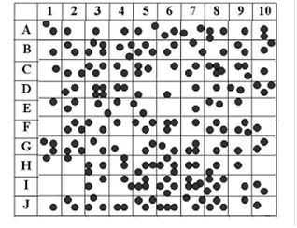

|  |  |  |
| --- | --- | --- |
| **Letter** | **Number** | **Number of Trees in this quadrant** |
|  |  |  |
|  |  |  |
|  |  |  |
|  |  |  |
|  |  |  |
| Total Trees number in 5 quadrants (1/20 of a sq km) | | = |
| Total Trees estimate in 100 quadrants – the whole square (1 sq km) | | = |
| Total tree estimate in 1000 sq kms | | = |